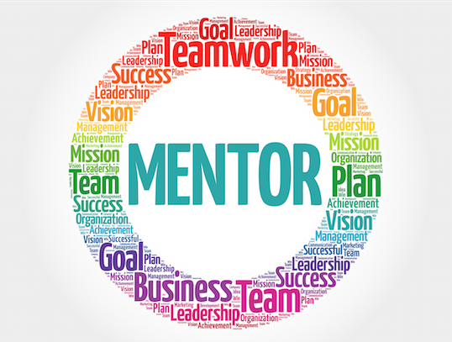
Mentorship Plan.
I am Currently undertaking Data science at Moringa School for 23 weeks with the hope to become a successful data Scientist who is well equipped with knowledge. Finding a mentor who is well into the field will be of great impact as they will assist in steering me in the right direction.

1. What would you like to learn?
I would like to know more of the tools required to make a well equipped data scientist as well as Projects that I can undertake to better my knowledge in Machine learning.

2. What are you looking for from your mentor?
I am Looking for a mentor who is willing to take me through my journey in Moringa School. A mentor who has a lot of experience in the data science work industry and can give me leads on companies that i can join to expand my school gained knowledge. Lastly,a mentor who gives positive criticism as a way to help me grow.

3. How often would you like to meet? Where?
We would probably schedule meet ups depending on our availability but as frequently as we possibly can.The meeting venue should also be places where we can conducively talk about data science projects, probably over coffee or within a data science related workshop.
I would also like to receive comments on my code on a daily basis so I can work on improving on my weak areas
My List of possible Mentors.
- Chris Orwa
- Samuel Karuga
- Alex Gakuru
- Milka Gesicho
Think about what you'll say.
When approaching my mentor,I would mention how commendable their work is and inform them that I would appreciate it if they would assist me grow in the data science field .
Start approaching your potential mentors.
I will approach my possible mentors through the contact emails they have provided in their profiles or through their LinkedIn pages. I will then await their responses. I will take their responses positively. If none agrees, I will look into getting another list of possible mentors.
Show your appreciation
I will constantly show my mentor appreciation in a professional way each time I succeed in my projects. I will also be sending my mentor my daily codes so they can assess my work and give their feedback.

